Java Programming Cheatsheet

This appendix summarizes the most commonly-used Java language features in the textbook. Here are the [APIs](http://introcs.cs.princeton.edu/java/11cheatsheet/api.pdf) of the most common libraries.

**Hello, World.**

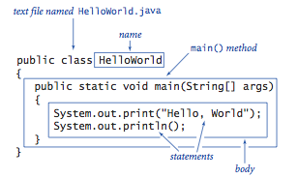

**Editing, compiling, and executing.**

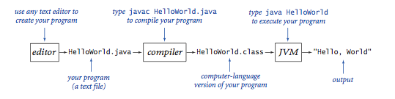

**Built-in data types.**

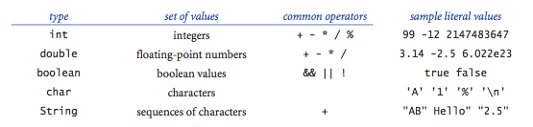

**Declaration and assignment statements.**

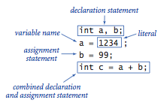

**Integers.**

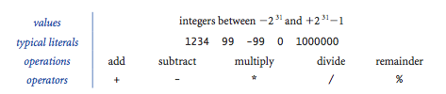

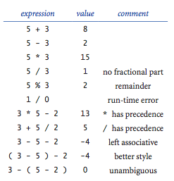

**Floating-point numbers.**

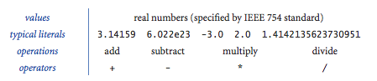

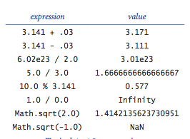

**Booleans.**

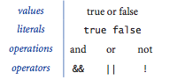

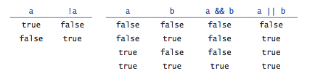

**Comparison operators.**

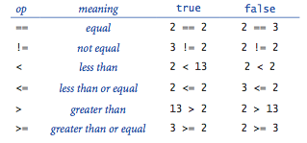

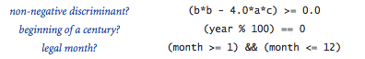

**Parsing command-line arguments.**

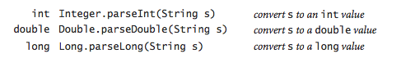

**Math library.**

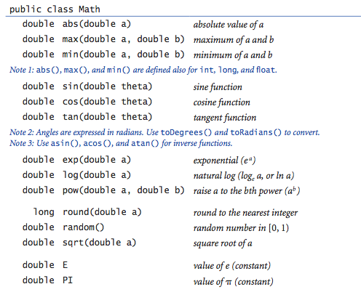

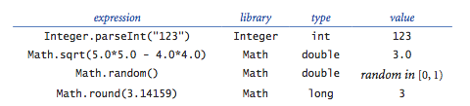

The full [java.lang.Math API](http://docs.oracle.com/javase/6/docs/api/java/lang/Math.html).

**Type conversion.**

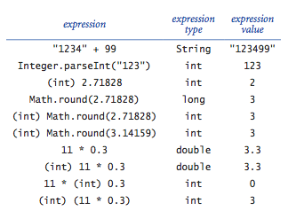

**If and if-else statements.**

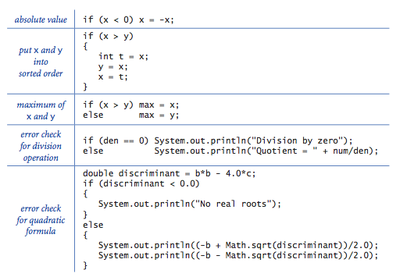

**Nested if-else statement.**

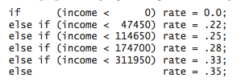

**While and for loops.**

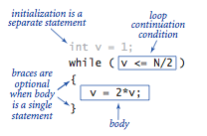       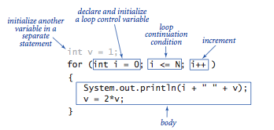

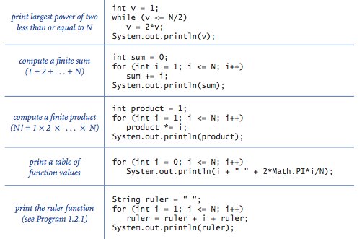

**Break statement.**

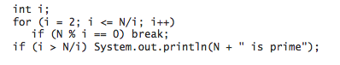

**Do-while loop.**

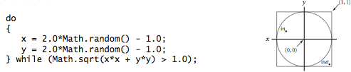

**Switch statement.**

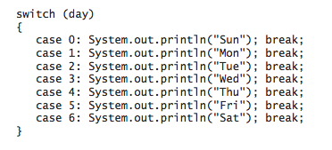

**Arrays.**

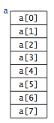

Compile-time initialization.

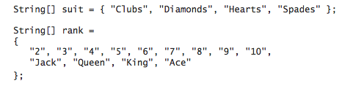

Typical array-processing code.

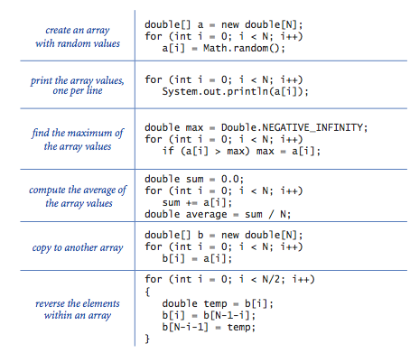

**Two-dimensional arrays.**

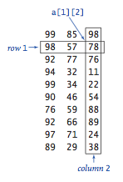

Compile-time initialization.

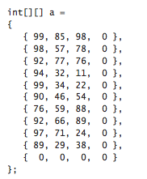

Ragged arrays.

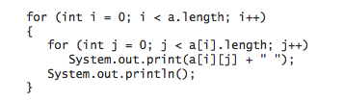

**Our standard output library.**

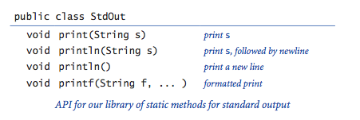

The full [StdOut API](http://introcs.cs.princeton.edu/java/stdlib/javadoc/StdOut.html).

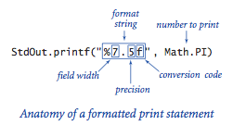

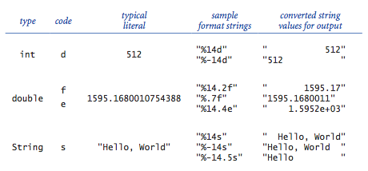

**Our standard input library.**

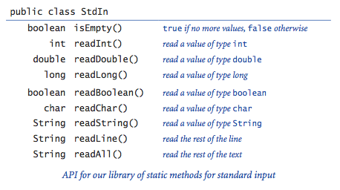

The full [StdIn API](http://introcs.cs.princeton.edu/java/stdlib/javadoc/StdIn.html).

**Our standard drawing library.**

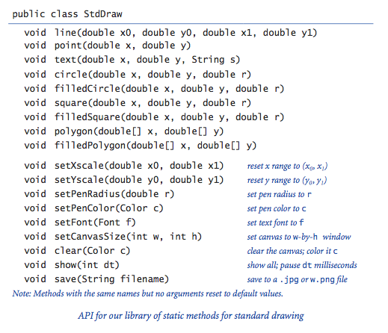

The full [StdDraw API](http://introcs.cs.princeton.edu/java/stdlib/javadoc/StdDraw.html).

**Our standard audio library.**

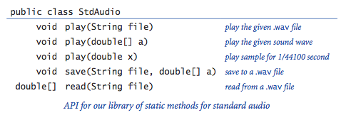

The full [StdAudio API](http://introcs.cs.princeton.edu/java/stdlib/javadoc/StdAudio.html).

**Redirection and piping.**

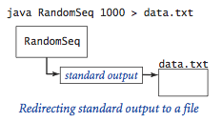                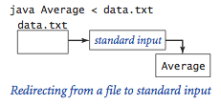

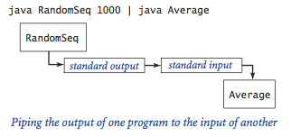

**Functions.**

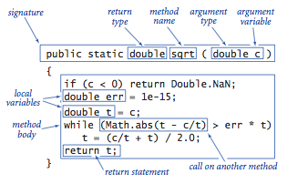

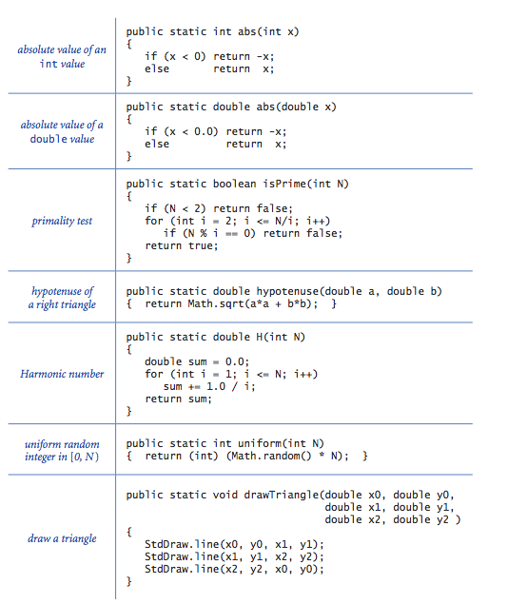

**Libraries of functions.**

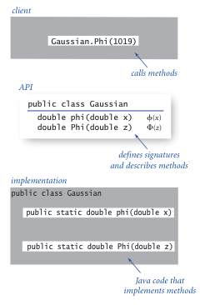

**Our standard random library.**

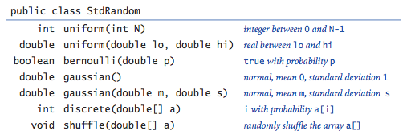

**Our standard statistics library.**

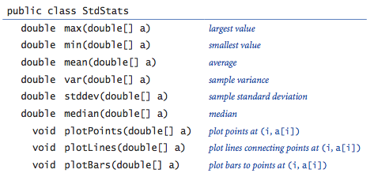

**Using an object.**

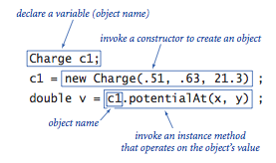

**Creating an object.**

Instance variables.

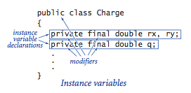

Constructors.

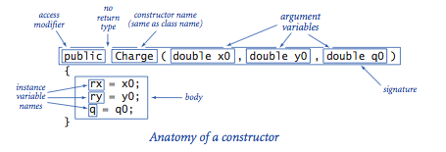

Instance methods.

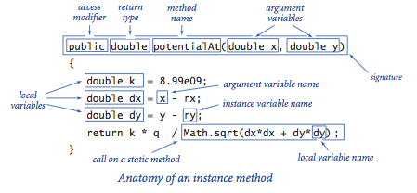

**Classes.**

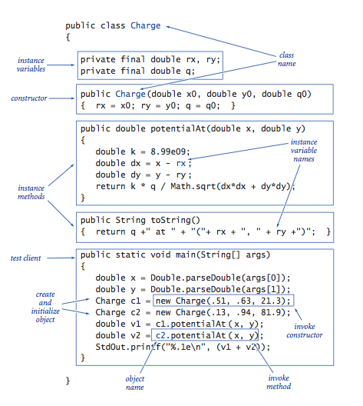

**Object-oriented libraries.**

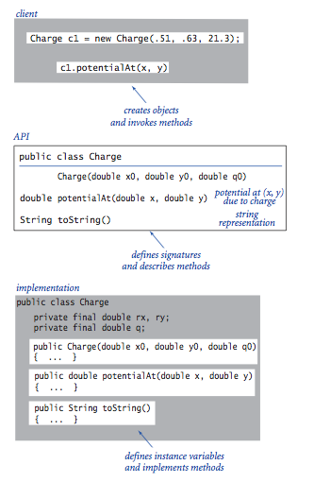

**Java's String data type.**

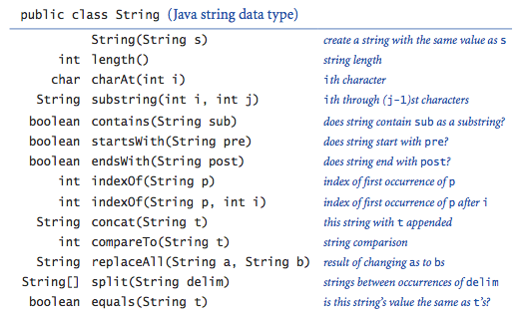

The full [java.lang.String API](http://docs.oracle.com/javase/6/docs/api/java/lang/String.html).

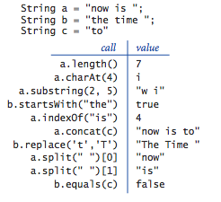

*Note*: the [java.lang.StringBuilder](http://docs.oracle.com/javase/6/docs/api/java/lang/StringBuilder.html) API is similar, but StringBuilder supports some operations more efficiently than String (notably, string concatenation) and some operations less efficiently (notably, substring extraction).

**Java's Color data type.**

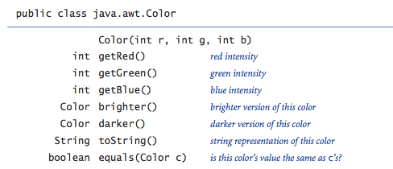

The full [java.awt.Color API](http://docs.oracle.com/javase/6/docs/api/java/awt/Color.html).

**Our input library.**

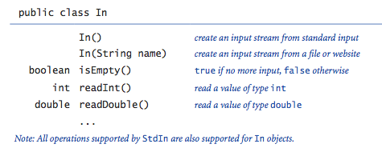

The full [In API](http://introcs.cs.princeton.edu/java/stdlib/javadoc/In.html).

**Our output library.**

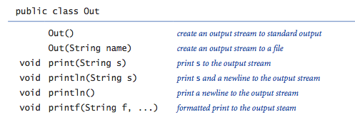

The full [Out API](http://introcs.cs.princeton.edu/java/stdlib/javadoc/Out.html).

**Our picture library.**

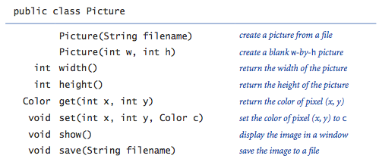

The full [Picture API](http://introcs.cs.princeton.edu/java/stdlib/javadoc/Picture.html).